5th February 2014

**YOKOHAMA to Sponsor US LPGA Tournament in Alabama**

Tokyo —The Yokohama Rubber Co., Ltd., announced today that its US subsidiary, the Yokohama Tire Corporation (YTC), has entered into a multiyear contract to sponsor an annual US Ladies Professional Golf Association (LPGA) tournament held in Alabama. The tournament will become known as the Yokohama Tire LPGA Classic. This year’s tournament will be held 18-21 September in Prattville, Alabama, on the Senator Course at Capitol Hill along the Robert Trent Jones (RTJ) Golf Trail. The Prattville course of the RTJ Golf Trail has been the site of historic LPGA moments, including two championships by Lorena Ochoa and a win by Lexi Thompson that made her the youngest winner in LPGA history at that time.

Through its sponsorship of the LPGA tournament, YTC aims to further strengthen marketing of its tyres in the US. YTC has been expanding its sports marketing program, which already includes partnerships with the National Basketball Association’s Los Angeles Clippers; the National Football League’s Indianapolis Colts and Baltimore Ravens; and Major League Baseball’s Los Angeles Angels of Anaheim and New York Yankees.

In 2008, Yokohama Rubber launched the Yokohama Tire Golf Tournament PRGR Ladies Cup, one of the tournaments of the Ladies Professional Golfers' Association (LPGA) of Japan. The 7th PRGR Ladies Cup will be held 14-16 March at the Tosa Country Club in Kochi Prefecture.



*Logo mark of the Yokohama Tire LPGA Classic*

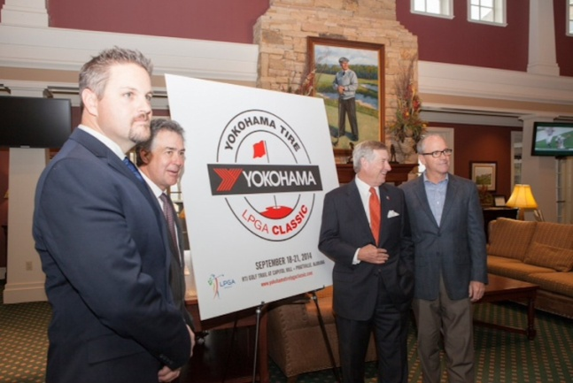

L-R: Andrew Briggs, YTC Director, Product Planning and Marketing; Prattville, Alabama Mayor Bill Gillespie Jr.; Montgomery, Alabama Mayor Todd Strange; and John Cannon, President of the RTJ Golf